**Low Earth orbit**

From Wikipedia, the free encyclopedia

[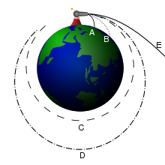](http://en.wikipedia.org/wiki/File:Newton_Cannon.svg)

An orbiting cannon ball showing various sub-orbital and orbital possibilities.

[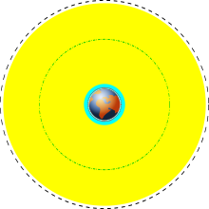](http://en.wikipedia.org/wiki/File:Orbits_around_earth_scale_diagram.svg)

Various earth orbits to scale; light blue represents low earth orbit.

[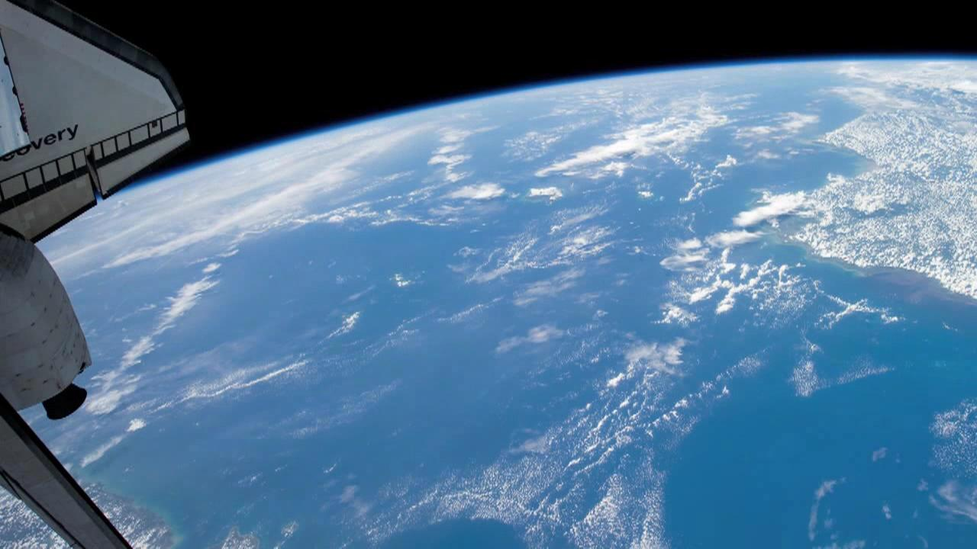](http://en.wikipedia.org/wiki/File:Sunrise_To_Sunset_Aboard_The_ISS.OGG)

Roughly half an orbit of the ISS.

A **low Earth orbit** (**LEO**) is generally defined as an orbit within the locus extending from the Earth’s surface up to an altitude of 2,000 km. Given the rapid orbital decay of objects below approximately 200 km, the commonly accepted definition for LEO is between 160 - 2,000 km (100 - 1,240 miles) above the Earth's surface.

With the exception of the lunar flights of the Apollo program, all human spaceflights have been either in LEO or have been sub-orbital. The altitude record for a human spaceflight in LEO was Gemini 11 with an apogee of 1,374.1 km.

**Orbital characteristics**

Objects in LEO encounter atmospheric drag in the form of gases in the thermosphere (approximately 80–500 km up) or exosphere (approximately 500 km and up), depending on orbit height. LEO is an orbit around Earth between the atmosphere and below the inner Van Allen radiation belt. The altitude is usually not less than 300 km because that would be impractical due to the larger atmospheric drag.

Equatorial low Earth orbits (ELEO) are a subset of LEO. These orbits, with low inclination to the Equator, allow rapid revisit times and have the lowest delta-v requirement of any orbit. Orbits with a high inclination angle are usually called polar orbits.

Higher orbits include medium Earth orbit (MEO), sometimes called intermediate circular orbit (ICO), and further above, geostationary orbit (GEO). Orbits higher than low orbit can lead to earlier failure of electronic components due to intense radiation and charge accumulation.

**Human use**

The International Space Station is in a LEO that varies from 319.6 km (199 mi) to 346.9 km (216 mi) above the Earth's surface.

While a majority of artificial satellites are placed in LEO, where they travel at about 27,400 km/h (8 km/s), making one complete revolution around the Earth in about 90 minutes, many communication satellites require geostationary orbits, and move at the same angular velocity as the Earth. Since it requires less energy to place a satellite into a LEO and the LEO satellite needs less powerful amplifiers for successful transmission, LEO is still used for many communication applications. Because these LEO orbits are not geostationary, a network (or "constellation") of satellites is required to provide continuous coverage. Lower orbits also aid remote sensing satellites because of the added detail that can be gained. Remote sensing satellites can also take advantage of sun-synchronous LEO orbits at an altitude of about 800 km (500 mi) and near polar inclination. ENVISAT is one example of an Earth observation satellite that makes use of this particular type of LEO.

Although the Earth's pull due to gravity in LEO is not much less than on the surface of the Earth, people and objects in orbit experience weightlessness due to the effects of freefall.

Atmospheric and gravity drag associated with launch typically adds 1,500-2,000 m/s to the delta-v launch vehicle required to reach normal LEO orbital velocity of around 7,800 m/s (17,448 mph).

[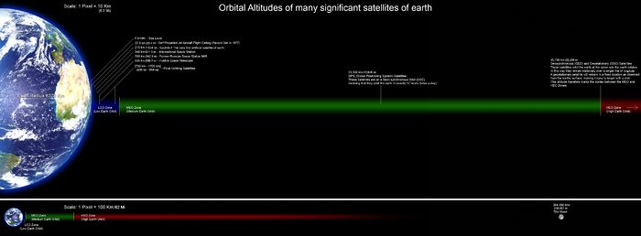](http://en.wikipedia.org/wiki/File:Orbitalaltitudes.jpg)

**Space debris**

The LEO environment is becoming congested with space debris which has caused a growing concern in recent years, since collisions at orbital velocities can be highly damaging or dangerous and can produce even more space debris in the process, called the Kessler Syndrome. The Joint Space Operations Center, part of United States Strategic Command (formerly the United States Space Command), currently tracks more than 8,500 objects larger than 10 cm in LEO, however a limited Arecibo Observatory study suggested there could be about one million objects larger than 2 millimeters, which are too small to be seen from the ground.

**See also**

* [List of orbits](http://en.wikipedia.org/wiki/List_of_orbits)
* [Escape velocity](http://en.wikipedia.org/wiki/Escape_velocity)
* [Medium Earth Orbit](http://en.wikipedia.org/wiki/Medium_Earth_Orbit) (MEO)
* [Highly Elliptical Orbit](http://en.wikipedia.org/wiki/Highly_Elliptical_Orbit) (HEO)
* [Specific orbital energy examples](http://en.wikipedia.org/wiki/Specific_orbital_energy#Examples)
* [International Space Station](http://en.wikipedia.org/wiki/International_Space_Station)
* [Atmospheric reentry](http://en.wikipedia.org/wiki/Atmospheric_reentry)
* [Satellite phone](http://en.wikipedia.org/wiki/Satellite_phone)